
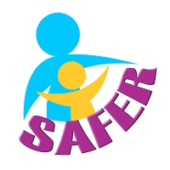
Code of Conduct

AS AN ADULT MEMBER I WILL

- Treat everyone with respect and dignity and help anyone as needed
- Ensure that the welfare and safety of all members is paramount
- Adhere to child and vulnerable adults safeguarding guidelines
- Always act in an appropriate way and challenge bullying, swearing or other disruptive or discriminatory behaviour
- Liaise openly with parents, carers, coaches and all other members
- Listen to, and act upon, any disclosures, allegations or concerns of child abuse, the welfare of children or vulnerable adults
- Attend Safeguarding training every 3 years

Name: ……………………………………………………………

Signed: ……………………… Date………………………….
_____________________________________________________________

OR AS A YOUTH MEMBER I WILL

- Treat everyone as I would like to be treated
- Arrive on time with the correct clothes and equipment
- Help anyone as needed
- Be friendly, and respect all other members, coaches and volunteers
- Follow the rules
- Speak to coaches, volunteers or welfare officers, if I have any worries

Name: ……………………………………………………………..

Signed: …………………….. Date: ……………………..

Code of conduct for trips / activities

If attending trips / activities I agree to the following :

- I will sign up promptly to activities once these are promoted
- I will provide the information requested by the organiser and respond to emails etc promptly
- I will pay for the activity when requested
- I will help to reduce transport costs by sharing transport where ever possible
- I will be on time and ensure I have the equipment needed for the activity
- I will help out during the activity

